


Anguilla Maritime Administration
& Shipping Registry

AMASR

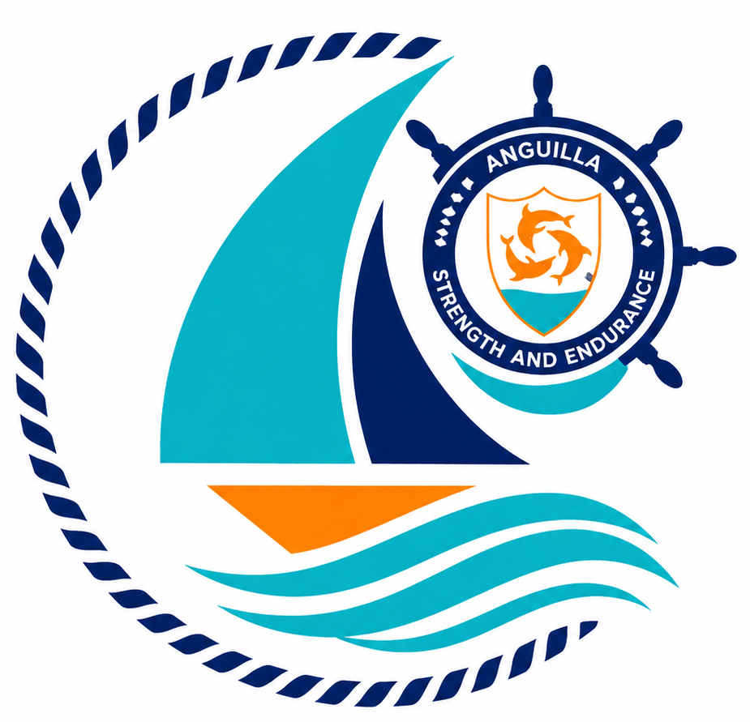

Form: | Application for Seafarers Documents
No.: | 08
Rev.: | 02  {STCW Certificate of Endorsement (CoE) attesting the recognition of another Administration’s Certificate and/or  Continuous Discharge Certificate (CDC) incorporating Seafarers Identification and Sea Service Record}
Date: | 2026-06-10
To: | Recognized Organizations, Shipowners, Managers, Masters, Seafarers, Partners, Brokers, Surveyors, and the general public.

Strength and Endurance

Address: Anguilla Maritime Administration
Anguilla, Leeward Islands, Ministry of Infrastructure, Communications, Utilities and Housing, Coronation Avenue, The Valley Anguilla
Tel: +447454760022| Email: info@amasr.ai

FORM 07 - APPLICATION FOR EXEMPTION
Please complete this form in its entirety, electronically or in block capitals.

TYPE OF APPLICATION  (please tick)  Maritime Registrar through which application submitted: | Joint Application  CDC & Certificate of Endorsement |  | Continuous  Discharge Certificate |  | Certificate of Endorsement |  | GMDSS
 | Ship Security Officer |  | Tanker |  | Renewal/  Replacement |  | Other

PART A – TO BE COMPLETED BY ALL SEAFARERS
PERSONAL DETAILS OF SEAFARER
1) Surname: |  |  |  |  |  |  | 2) Given name(s):
Home Address of  Seafarer: |  | Documents will be sent to this address unless the application is made through the Dept. of Maritime Affairs, the office of a Maritime Registrar or other party (e.g. Owner, Crew Manager) when they will be sent to that office for passing onto the seafarer
3) Address Line 1
4) Address Line 2
5) Town/City |  |  |  |  |  |  |  |  |  |  | 6) Post/Zip Code
7) County/State |  |  |  |  |  |  |  |  |  |  | 8) Country
9) Tel: |  |  |  |  | 10) Email:
11) Passport No: (see Notes on pg 3) |  |  | 12) AMASR Seafarers No: (renew/replace) |  |  |  |  | 13) Date of birth (dd/mm/yy): |  |  |  | 14) Place of birth:
15) Nationality: |  |  | 16) Medical Certificate Issue Date: |  |  |  |  | 17) Medical Certificate Expiry Date: |  |  |  | 18) Sex (M/F):
DETAILS OF NEXT OF KIN OR PERSON WHO CAN BE CONTACTED IN CASE OF AN EMERGENCY
19) Name (Family name, Given name): |  |  |  |  |  |  | 20) Relationship (e.g. Mother, Wife, Friend):
21) Address (If same as seafarer, state “same as above”):

22) Address
23) Town/City |  |  |  |  |  | 24) County/State
26) Post/Zip Code |  |  |  |  |  | 27) Country
28) Tel: |  |  |  |  | 29) Email:

PART B – TO BE COMPLETED BY APPLICANTS REQUIRING A CERTIFICATE OF ENDORSEMENT
DESCRIPTION OF HIGHEST GRADE OF CERTIFICATE NOW HELD
30) Capacity: |  |  |  |  |  | 31) Date of Issue: (dd/mm/yy) |  |  |  | 32) Date of Expiry: (dd/mm/yy)
33) Certificate No: |  |  | 34) Name of Issuing Authority (Flag State) :
35) ADDITIONAL ENDORSEMENT REQUESTED (if required, tick box)
GOC (GMDSS) |  | Chemical Tanker |  |  | Gas Carrier |  | Oil Tanker |  | Ship Security Officer
Other
36) Date of Issue of current endorsement: |  |  |  |  |  | 37) Date of Expiry of current endorsement:
38) Endorsement No: |  |  |  |  |  | 39) Name of Issuing Authority (Flag State):

40) Seafarer’s shall receive familiarization and basic training or instruction in accordance with section A-VI/1 of the STCW code. The following certificate/s must be included with this application evidencing the applicant’s proficiency in the following Emergency, Occupational Safety, Medical Care and Survival Functions.

* Applicant’s proficiency as per regulations VI/1, 1-4 may be evidenced by one certificate covering all functions, or by certificates showing each function separately.

** For candidates for a certificate of proficiency as a ship security officer

(please tick in boxes below):
[ ] | Regulation VI/1-1 Competence in personal survival techniques | [ ] | Regulation VI/1-4 competence in personal safety and social responsibilities
[ ] | Regulation VI/1-2 Competence in fire prevention and fire fighting | [ ] | Regulation VI/5 - Proficiency for Ship Security Officers **
[ ] | Regulation VI/1-3 Competence in elementary first aid
41) REASON FOR REPLACEMENT OR RENEWAL
[ ] | Document is now expired or no more room for entries | [ ] | Document has been lost or damaged (please explain circumstances of loss below)
[ ] | Requires amending (state amendment below) | [ ] | Other (please explain in the box below)
Details:

42) PART C – DECLARATION – TO BE COMPLETED BY ALL SEAFARERS
I hereby declare that the information contained on this application is true and correct and I apply for the Seafarers documents requested. If I am applying for a Certificate of Endorsement issued under STCW Convention, at Management Level, I have familiarised myself with ANGUILLA Legislation as available on the website www.amasr.ai I am aware that if I submit fraudulent documents, I may be banned from serving on ANGUILLA ships and liable for prosecution.

Signature of Seafarer |  | Date of Application

PART D – SUPPORTING DOCUMENTS REQUIRED WITH APPLICATION
SUPPORTING DOCUMENTS REQUIRED (all applications): |  | Attached (please tick) | For Official use
1 | Copy of passport – showing personal details of Applicant as per those entered on this Application Form
2 | 1 x Passport size photo
3 | Valid Medical Fitness Certificate (the medical examination must be carried out no more than 18 months before this application)
4 | CDC Only : Copies of training certificates (as outlined in 40), above)
5 | Payment or Proof of payment of Fees
6 | Any other documentation AMASR Reg may deem necessary for this application (if requested)
7 | Certificate of Proficiency for Security Awareness Training (VI/5) or Security Training for Seafarers with Designated Security Duties (VI/6)
In addition - for Continuous Discharge Certificate (CDC)
7 | Current CDC (if requesting renewal/replacement)
In addition - for Certificate of Endorsement (CoE)
8 | Copy of current Certificate of Competency (COC) from the home country of the applicant or a country listed in the "White List" of the IMO.
9 | Copy of current additional Endorsement (GMDSS, Tanker, Ship Security Officer etc) (if applying for this)
10 | Proof of Sea Service – copy of sea service certificates or pages from seaman’s book showing personal details and ranks served
11 | Current CoE (if applying for extension)

Note: Refer also to the guidance notes overleaf.

Applying for Seafarer Documents?
Do you have the following?
Application form
for
CDC, CoE or
Additional Endorsement
Other Endorsement
SKN number
Copy of GMDSS,
SSO, Tanker or
other certificate.
CDC
Passport,
Valid Medical certificate,
Basic Training Certificates
Passport size photo
Security Familiarisation (if applicable).
COE
Copy of current CoC
from a country
listed in the
“White List” of the IMO

Need a CDC?
Already hold a SKANReg CDC?

PLEASE RETAIN THIS PRIVACY POLICY

ANGUILLA MARITIME ADMINISTRATION & SHIPPING REGISTRY Privacy Policy

In accordance with EU General Data Protection Regulation (“GDPR”), as of 25th May 2018, the following constitutes ANGUILLA MARITIME ADMINISTRATION & SHIPPING REGISTRY Data Protection Policy.

ANGUILLA MARITIME ADMINISTRATION & SHIPPING REGISTRY intentions are to adopt and embrace the purposes, principals, obligations and rights in accordance with GDPR as mentioned below.

ANGUILLA MARITIME ADMINISTRATION & SHIPPING REGISTRY recognise the purposes of GDPR which are an update of existing Data Protection Rules:

- An update of the existing Data Protection Rules
- Fix the shortcomings of data protection laws
- Update definitions of personal data
- Take a risk based approach

And the following principles of GDPR:

- Lawfulness, fairness and transparency
- Purpose limitation.
- Data minimisation
- Accuracy
- Storage limitation
- Integrity and confidentiality
And Obligations of GDPR:

- Breach Notifications
- Transparency
- Data Protection Officer

ANGUILLA MARITIME ADMINISTRATION & SHIPPING REGISTRY recognises the following rights of the data subject according to GDPR:

- Right to be informed
- Right of access
- Right to rectification
- Right to erasure
- Right to be forgotten
- Right to restrict processing
- Right to data portability
- Right to prevent automated individual decision making and profiling

The following has been undertaken by ANGUILLA MARITIME ADMINISTRATION & SHIPPING REGISTRY to ensure that the above mentioned principals, obligations of GDPR and rights of the Data Subject are protected:

Data Protection Officer

Tracy Newson, General Manager will act in this capacity.

The Data Protection Officer will be responsible for enforcing Data Protection Policy and will make all steps possible to ensure this complies with GDPR.

The Data Subjects (persons from whom ANGUILLA MARITIME ADMINISTRATION & SHIPPING REGISTRY collect data for the purpose of issuing documents) will be notified of their rights and obligations of GDPR. In the case of a data breach then the ICO (Information Commissioners Office) will be contacted within 72 hours of the breach.

For seafarers completing our A15 Application Form for seafarer documentation, you are agreeing to allow us to hold data belonging to you on our database that we use to issue your AMASR documentation. We will hold this information as it will be used to verify the documents you are applying for/have been issued, by Owners / Managers & Port State Control.
If you would prefer not to hear from us, or if you wish to exercise any of your rights under data protection law including the right to object, please tell us by email to crew@amasr.ai or by phone on +44 (0)1723 333 412.
We do not share your information with any third party for marketing purposes.
In line with GDPR, ANGUILLA MARITIME ADMINISTRATION & SHIPPING REGISTRY have entrusted their IT Service Provider (Utilize) to provide a secure network which is protected through passwords, antivirus software, a dedicated managed firewall and is regularly backed up and monitored by Utilize. We have an incremental data back-up every 15 minutes. All data held off site is encrypted to an ISO 9001:27001 accredited datacentres and is FIPS 140-2 certified encrypted.

All data input to our Seafarer HQ software is held off site and on the servers of Vessel HQ who host a secure network which is protected through passwords, antivirus software, a dedicated managed firewall and is regularly backed up and monitored.
ANGUILLA MARITIME ADMINISTRATION & SHIPPING REGISTRY shreds any personal or commercially sensitive documents through On Time Shred who have full adherence to European Standard EN15713. All On Time Shred staff are vetted to BS7858 as well as full CRB checked.

ANGUILLA MARITIME ADMINISTRATION & SHIPPING REGISTRY does not purchase or sell any data about companies or individuals.

ANGUILLA MARITIME ADMINISTRATION & SHIPPING REGISTRY does not purchase, sell or store data about members of the public who have not had any direct contact with ANGUILLA MARITIME ADMINISTRATION & SHIPPING REGISTRY.

It is strictly forbidden for any ANGUILLA MARITIME ADMINISTRATION & SHIPPING REGISTRY employee to release any data stored on the company server or company emails without prior written consent by a director of the company.

